IOT BASED SMART LIGHT AND VEHICLE CROSSING ALERT WITH INDICATION SYSTEM IN HILL STATION

# A PROJECT

**JIT 1731: PROJECT WORK PHASE** -**II IV YEAR / VIII SEM**

# R2019

*Submitted by*

# SAKTHI DHASAN K (130720205305)

**DHILIP KUMAR D (130720205303)**

*in partial fulfilment for the award of the degree of*

# BACHELOR OF TECHNOLOGY

*in*

# INFORMATION TECHNOLOGY



**JERUSALEM COLLEGE OF ENGINEERING**

## (An Autonomous Institution, Affiliated to Anna University, Chennai)

NBA & NAAC ACCREDITED INSTITUTION

Velachery Main Road, Narayanapuram, Pallikaranai, Chennai – 600 100

# APRIL 2024

**BONAFIDE CERTIFICATE**

Certified that this project report **“ IOT BASED SMART LIGHT AND VEHICLE CROSSING ALERT WITH INDICATION SYSTEM IN HILL STATION ”** is the bonafide work of **“** **SAKTHI DHASAN K ( 1 3 0 7 20205305 ) , DHILIP KUMAR D ( 1 3 0 7 20205303 ) , ”** who carried out the project work under my supervision.

|  |  |
| --- | --- |
| **SUPERVISOR** | **HEAD OF THE DEPARTMENT** |
| **Ms. M. A CHRISTY GRACE**  **M.E.,(Ph.D)** | **Dr. K. SUNDARAMOORTHY Ph.D.,** |
| Assistant Professor | Professor and HEAD |
| Department of Information Technology | Department of Information Technology |
| Jerusalem College of Engineering | Jerusalem College of Engineering |
| Pallikaranai, Chennai-600 100 | Pallikaranai, Chennai-600 100 |

Submitted to the project viva-voce exam held-on ……………….

**INTERNAL EXAMINER EXTERNAL EXAMINER**

# ACKNOWLEDGEMENT

We would like to extend our sincere thanks and gratitude to our honorable Chairperson, **Prof**. **Dr**. **M. MALA M.A., M.Phil.**, our Principal **Dr. S. RAMESH**, for providing us all the facilities and resources required to complete our project successfully.

We find no words to express our deep sense of gratitude to **Dr. K. SUNDARAMOORTHY M.E., PhD.,** Professor and Head, Department of Information Technology, for being a constant source of inspiration throughout the course of our project.

We thank our Project Coordinator **Mr. K. ARUN PRASAD M.Tech (PhD),** Assistant Professor, for their advice and assistance in keeping our progress on schedule.

We express our deep sense of gratitude to our supervisor, **Ms. M.A. CHRISTY GRACE M.E ., (PhD),**Assistant Professor of our Department, for her valuable guidance and useful suggestions, which helped us in completing this project successfully.

Our grateful thanks are also extended to all our department faculty members for their valuable technical support on this project. Finally, we thank almighty, our parents and friends for their constant encouragement without which this project work would not be possible.

SAKTHI DHASAN K

DHILIP KUMAR D

The project is IoT Based Smart lights And Vehicle Crossing Alert with Indication Systems In Hill Station With the help of an PIR Sensor, we will control the smart light and alert the crossing vehicles.

When if any vehicle is crossing the sensor above the lights blow automatically because of the sensor triggered.

This project presents an advance lighting system to minimize the wastage of electrical power and save electricity. For this purpose we are using Arduino, Light Dependent Resistor(LDR) and Passive Infrared (PIR) motion sensor. Light will be switched on when LDR detects moment.

We are using LDR to reduce unnecessary wastage of power during daytime and increase the efficiency of system. This project can also work as a security system. This project can also be used in smart light system.

As a result, vehicles must use extreme caution when driving through hairpin curves. These problems are the major concerns in hilly areas.

So the proposed system will help to avoid accidents at hairpin bends and save lives. The proposed system reduces accidents in hairpin bends and there is less traffic congestion.

|  |  |  |
| --- | --- | --- |
| **CHAPTER** | **TITLE** | **PAGE NO** |
|  | **ACKNOWLEDGMENT** | iii |
|  | **ABSTRACT** | iv |
|  | **LIST OF FIGURES** | vi |
| **1** | **INTRODUCTION** | 1 |
|  | * 1. OBJECTIVE   2. AIM   3. IOT | 2 |
| **2** | **LITERATURE REVIEW** |  |
|  | 2.1 ACCIDENT AVOIDANCE AND VEHICLE DETECTION IN HAIRPIN CURVES USING MACHINE LEARNING | 4 |
|  | 2.2 SMART LIGHT USING PIR SENSOR | 5 |
|  | 2.3 COLLISION AVOIDANCE AT HAIRPIN CURVES USING SENSORS | 6 |
|  | 2.4 DC SMART STREET LIGHTING PROJECT | 7 |
|  | 2.5 SMART LIGHTS USE HILLS STATION VEHICLE CROSSING | 8 |
|  | 2.6 VEHICLE CROSS INDICATING USING PIR IN HILLS STATION | 9 |
| **3** | **IOT BASED SMART LIGHTS & VEHICLE CROSSING ALERT WITH INDICATION** |  |
|  | 3.1 PROPOSED SYSTEM | 10 |
|  | 3.2 METHODOLOGY | 17 |
|  | 3.3 ARCHITECTURE | 18 |
| **4** | 3.4 ALGORITHMS USED  **METHOD AND TECHNOLOGIEES INVOLVED** | 19 |
|  | 4.1 SOFTWARE COMPONENTS | 20 |
|  | 4.2 MODULES | 20 |
|  | 4.3 PIR SENSOR  4.3.1 IR SENSOR | 21  22 |
|  | 4.3.2 SSR RELAY | 23 |
|  | 4.4 MICROCONTROLLER | 24 |
| **5** | **ANALYZED SCENARIO**  5.1 CIRCUIT DIAGRAMS  5.1.1 ALERT WITH INDICATE CIRCUIT DIAGRAM  5.1.2 SMART LIGHTS CIRCUIT DIAGRAM | 25  25  25 |
|  | 5.2 OUTCOME OF THE SYSTEM  5.3 FINAL OUTCOME  5.4 CONCLUSION    REFERENCES  **APPENDICES**  APPENDIX - I  SOURCE CODE  APPENDIX – II  PUBLICATIONS | 26  27  28  29  30  35 |
|  |  |  |
|  |  |  |
|  |  |  |

# FIGURE NO

**TITLE PAGE NO**

2.1 HAIRPIN BEND CURVE 4

2.2 ALART LIGHTS 8

2.3 BLOCK DIAGRAM OF INDICATE 9

3.1 METHODOLOGY 17

3.2 ARCHITECTURE 18

4.1 PIR SENSOR 21

4.2 IR SENSOR 22

4.3 SSR RELAY 23

4.4 MICROCONTROLLER 24

5.1 ALERT WITH INDICATE CIRCUIT DIAGRAM 25

5.2 SMART LIGHTS CIRCUIT DIAGRAM 25

5.3 OUTCOME OF THE SYSTEM 26

5.4 FINAL OUTCOME 27

**vi**

# INTRODUCTION

Hairpin turns are often built when a route climbs up or down a steep slope, so that it can travel mostly across the slope with only moderate steepness and are often arrayed in a zigzag pattern. Highways with repeating hairpin turns allow easier, safer ascents and descents of mountainous terrain than a direct, steep climb and descent, at the price of greater distances of travel and usually lower speed limits, due to the sharpness of the turn. Highways of this style are also generally less costly to build and maintain than highways with tunnels. Hairpin curves are used when the terrain is very steep. Roadways will have a maximum grade that a vehicle or truck can traverse.

The zigzag component of the picture above minimizes the grade, or steepness of the roadway. If you have ever ridden a bike up a steep hill, you might have found yourself zigzagging back and forth across the roadway to get up the hill. The same principle applies here. When designing a roadway, there are guidelines as to the length of the radius of curve based primarily on the design speed.

The faster the designs speed, the longer the radius of the curve. Truck traffic is a major factor in the design criteria for the minimum radius of curvature. Turning templates are used to determine if a truck can make the turn without too much of tracking. A bend in a road with a very acute inner angle, making it necessary for an oncoming vehicle to turn almost 180° to continue on the road.

The main reason behind this accident is curves and bends of roads while turning in Ghats. It becomes difficult to see vehicles coming from other lane and turning drivers usually have to assume a way for turning at such critical section this creates a great risk of life other reason for accident in hairpin section is that only one vehicle can turn at turnings at a time. If two vehicles come face to face while turning, it creates a chance of accidents and it becomes difficult to handle.

At night, due to no streetlights it becomes a difficult task of driving on hairpin bends and especially while turning. It becomes more difficult at night to make a turn as vehicle coming from another side of road is not visible due to darkness.

# PROBLEM DEFINITION:

Drivers face the risk of accidents when driving on hairpin bends due to lack of communication and zero visibility over the hairpin curves.

Alerting the driver about the vehicles coming from the opposite side in Ghats sections by keeping an ultrasonic sensor on one side of the road before the curve and keeping a LED light after the curve.

Averting collisions between vehicles mainly occurring in hairpin bends, short corners, blind curves, etc. using Arduino microcontroller.

Driving is one of the most challenging tasks in the hills. While driving in these areas, drivers must stay alert at all times. The driver does not see the car approaching from the opposite side in curves and hairpin bends, which is one of the leading causes of accidents in mountainous areas.

A multitude of curves and hairpin bends can be found in mountainous areas. In these areas, the roadway is a popular form of transportation. In hilly areas, the number of accidents and deaths is steadily rising. Because the roads in this area will almost certainly feature twists and sharp curves, it will be difficult to see vehicles approaching from the other direction.

This paper detects the presence of vehicle on one side of the curve using camera, classifies the following vehicle into ‘light’ or ‘heavy’ vehicle category and alert the vehicles on other side of the curve using LED display board. Our specially designed LED display board consists of information such as vehicle class and traffic signals which is used to alert the driver about the upcoming opposite vehicle.

This paper alerting the driver of a car approaching from the opposite direction This is accomplished by placing an ultrasonic sensor on one side of the road before the curve and an LED light on the opposite side, such that when a vehicle approaches from one end of the curve, the sensor detects it and the LED light glows on the opposite side. The driver can become alert and slow down the car by looking at the LED light on/off indicator.

vehicle-to-hub Communication can assist in obtaining it. Safety and avoiding crashes are the primary motivations for car-to-car communication systems. Car-to-Hub communication This technology isn't tailored to a certain vehicle or manufacturer.

With some modification, this may be used in any vehicle. The technology is developed in such a way that it may be used by a regular car drivers. Automobiles have become one of humanity's greatest economic triumphs. In the last century, they were sadly prone to accidents and became victims while travelling.

Sensors monitor the position of the vehicles in relation to the hairpin turn to determine which Vehicles must move first. The system captures information exchange between vehicles. The decision regarding speed and distance is passed on to the vehicle via a visual display. based on algorithms. The hardware and software architecture are designed and developed. throughout the project is detailed in this paper.

This paper contains a set of ultrasonic sensors, warning lights combined with a convex mirror is installed by the side of the road. Wires link the sensors, which are mutually exclusive. The priority algorithm automatically limits vehicle travel at the hairpin curve based on sensor data, providing appropriate alerts when detection is detected. The appropriate warningis triggered for various scenarios, prioritizing the vehicle's movement. In the event of a system failure, a caution LED is activated, which sends a signal to the maintenance department.

The paper aims in reducing the risk of driving vehicle in the terrain region with hairpin bends and steep curves. The deployed controller with ultrasonic sensor detects the vehicle approaching the bend and alerts it to the other side of the bend or curve; it provides three levels of LED notifications to the driver approaching the hairpin bend or curve from the other side.

The planned system's primary goal is to reduce fatality rates in hilly areas by preventing accidents for both drivers and passengers. By storing data in the cloud, this method also allows for analysis of the number of uphill and downhill cars in hill stations. A web application is used to see the analyzed data over the internet. People who want to travel down that road can use the online application as a traffic pattern analyst.

# CHAPTER 2 LITERATURE REVIEW

2.1 ACCIDENT AVOIDANCE AND VEHICLE DETECTION IN HAIRPIN CURVES USING MACHINE LEARNING

## Description:

Vehicles play a significant part in our daily lives, such as commuting from one location to another, transporting goods, food, and so on, by reducing travel time for humans. According to past knowledge and reports many accidents occur on mountainous roads owing to the lack of vision of other vehicles approaching from the opposite direction, landslides, and adverse weather conditions. However, no safeguards or actions to avoid them have been implemented. Human life is lost as a result of this.

Vehicles moving through hairpin bends have a higher chance of accidents. Because there is a lack of visibility between vehicles in the hairpins, therefore, drivers must be extremely cautious in these deep curves while driving. also, there is traffic congestion due to unorganized movements.Vehicles are important in the day-to-day lives of every human being. Also, there is a high rate of accidents that occur due to high speeds and rash driving.

The situation in hilly areas is more dangerous. Because of hairpin bends, the vehicles have zero visibility. So the proposed system will help to avoid accidents at hairpin bends and save lives.

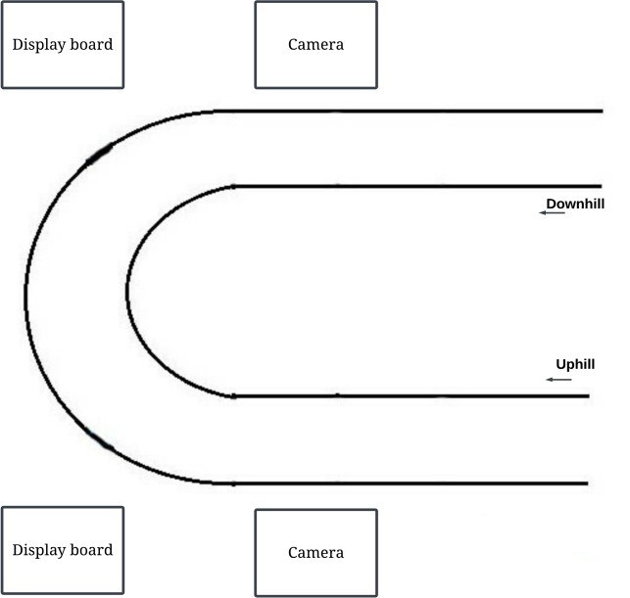

Fig 2.1: HAIRPIN BEND CURVE

## 4

**2.2 SMART LIGHT USING PIR SENSOR**

## Description:

Nowadays, energy consumption is large in residential and business areas. it's due to the inefficient usage of electrical loads like heating systems, lighting systems etc. Among these, the lighting system is one in all the biggest energy overwhelming units of any building & structure. it's thus crucial to use the good lighting system by automatically switch on/off or dim the lights when required without troubling the conventional operation of the working atmosphere.

Now a days, energy consumption is large in residential and business areas. it's due to the inefficient usage of electrical loads like heating systems, lighting systems etc. Among these, the lighting system is one in all the biggest energy overwhelming units of any building & structure. it's thus crucial to use the good and efficient lighting system by automatically switch on/off or dim the lights when required without troubling the conventional operation of the working atmosphere.

Different fields of lighting are business, residential, industrial and outside lighting. each of the sector has its own desires and necessities of lighting using completely different sensors. Residential sector wants to low power therefore low price easy solution will be used by using ambient sensors.

Industrial lighting in retailers and offices uses bit high power, so they will create use of passive infrared sensors or super sonic sensors to cover massive areas. outside and Industrial sectors will create use of Pyroelectric Infrared(PIR), light and motion sensors so as to manage the light in a very safety and value effective manner.

**2.3** **COLLISION AVOIDANCE AT HAIRPIN CURVES USING SENSORS**

## Description:

The project has been designed to prevent an accident by collision. This project proposes an idea to reduce the accidents and provide safety measuring techniques in hairpin curves using sensors, which detects the obstacles within 10 meters range of the vehicle using ultrasonic sensors.

If a vehicle is at 10 meters from the curve, then the sensor will automatically sense the signal and gives the signal to the driver coming in the opposite direction with a LED light and a buzzer. It uses two Ultrasonic sensors, which are placed on either side of the hairpin bend. One sensor S1 is installed by the side of the uphill section of the road, similarly other sensors S2 is installed by the side of the downhill section of the road.

The sensors are mutually connected to ESP8266 through wires. Based on the output of sensors, position of vehicles on either side of the bend is detected which is provided as an input to the Node MCU. The Node MCU which works on a power supply of 5V runs and triggers the warning LEDs to glow (L1 in Downhill or L2 in Uphill) and thereby intelligently controlling the movement of vehicles at the bend. Warning LEDs along with a Buzzer are placed at the either side of the curve of a hairpin bend.

They proposed a model which continuously track human motion. Output based on human tracking data which is obtained by these sensor are responsible for determining the On-Off control of the LED light. Existing system fails in continuously monitoring the motion of object by using each sensors separately. For same reason, the efficiency of existing system is low. By the hardware implementation they developed a model to improve the efficiency which helps in smart light. The proposed approach make use of sensors in which PIR sensor sends the sensed data to the MCU board which in turn send the same data to the LED control layer.

**2.4** **DC SMART STREET LIGHTING PROJECT**

## Description:

The LED technology that PIDC is implementing will make for roadways and walkways that are better lit, and the Remote Monitoring and Control System will ensure that assets are maintained (i.e. repaired/replaced) in a timely manner, both during and after the expiration of the project term. Additionally, PIDC will be installing wireless access points in several wards within the District.

This will empower those living in traditionally underserved neighborhoods to adopt remote work and school in communities where Wi-Fi may not always be available at home. Lastly, PIDC will invest in the local community by maintaining a team that consists of local and diverse suppliers and subcontractors, during both the D&C and Asset Management phases of work.

Alongside the efficient lighting technologies, the project will install smart city technology components, including a remote monitoring and control system and wireless access points to help solve inconsistent outage reporting. By delivering widescale Wi-Fi coverage, the DC Smart Street Lighting Project will help close the digital divide and advance D.C.’s progress toward its goal of citywide broadband access.

The project will not involve any changes to light pole placement or to the style of poles and luminaries, many of which reflect a historic design dating back to the 1920s; however, the streetlight upgrades will substantially reduce light pollution and improve pedestrian, cyclist and motorist safety. The project includes replacing ~75,000 street and alley lights with energy-efficient LEDs, including those that shine on “Welcome to Washington, D.C.” entrance signs, certain bike paths, underpass, and tunnel lights.

# they have already installed lighting of various methodology that are out- of-date and energy inefficient. For sensible lighting and to cut back the energy storage demand, light emitting diodes (LED) and hybrid installation will be used. Here, this paper offers a review on the obtainable smart lighting systems and it additionally offers the thought to develop low price.

**2.5 SMART LIGHTS USE HILLS STATION VEHICLE CROSSING**

## Description:

Nowadays, energy consumption is large in residential and business areas. it's due to the inefficient usage of electrical loads like heating systems, lighting systems etc. Among these, the lighting system is one in all the biggest energy overwhelming units of any building & structure. it's thus crucial to use the good lighting system by automatically switch on/off or dim the lights when required without troubling the conventional operation of the working energy consumption is large in residential and business areas. it's due to the inefficient usage of electrical loads like heating systems, lighting systems etc. Among these, the lighting system is one in all the biggest energy overwhelming units of any building & structure. it's thus crucial to use the good and efficient lighting system by automatically switch on/off or dim the lights when required without troubling the conventional operation of the working atmosphere.

Different fields of lighting are business, residential, industrial and outside lighting. each of the sector has its own desires and necessities of lighting using completely different sensors. Residential sector wants to low power therefore low price easy solution will be used by using ambient sensors. Industrial lighting in retailers and offices uses bit high power, so they will create use of passive infrared sensors or super sonic sensors to cover massive areas. outside and Industrial sectors will create use of Pyroelectric Infrared(PIR), light and motion sensors so as to manage the light in a very safety and value effective manner.

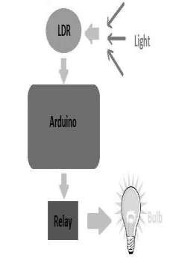

**2.6** **VEHICLE CROSS INDICATING USING PIR IN HILLS STATION**

## Description:

Mainly road accidents are caused due to High speed or when the driver is not aware of the other vehicles coming opposite to it especially in the deep curves. Such types of curves are called as HAIR PIN CURVES. The existing system makes use of convex mirrors at the curves so that the driver can easily detect the vehicle coming in the opposite direction. This system works well during the day but not effective in night.

The proposed system makes use of sensors at hairpin curves which work very efficiently during the night time. Placing the sensors at each side of the curves will help us to solve the problem. The usage of sensors is that if the vehicle is 10 meters away from the curve the sensor sends the signal to the vehicle coming in opposite direction in the form of light. In the same way the sensor at the other side of the curve will send signal to the vehicle coming from the opposite direction. In this way by using sensors we can avoid a greater number of accidents mainly at the deep curves. Reducing the rate of accidents increases the well-being of a person.

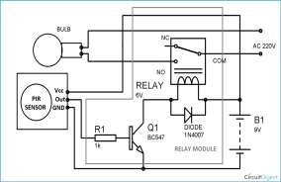

# CHAPTER 3

**IOT BASED SMART LIGHTS & VEHICLE CROSSING ALERT**

**WITH INDICATION**

# 3.1 PROPOSED SYSTEM

PIR sensor enable you to sense motion occured, nearly always used to find whether an individual's has enraptured in or out of sensors range. They are little, cheap, low power, simple to use and do not wear out. For that reason they are usually found in appliances and gadgets utilized in homes or industries. They are usually noted as PIR, " PassiveInfrared ", "Pyro electric", or " IRmotion " sensors.

PIRs are mainly made using a pyroelectric sensing element (which will|you will|you will be able to} see below because t spherical metal can with a rectangular crystal within the center), which might detects level of infrared radiation. Everything emit some low level radiations, and also the hotter something is in the range, the additional radiation will be emitted. The sensing element in motion detector is really split in into two halves inside the system.

The reason for that As a result, vehicles must take extreme caution when driving through hairpin curves. The existing systems detect only the incoming vehicles and not the type of vehicle. As a result, there is traffic congestion and delay in travel.

The proposed system is used to detect the vehicles on one side of the hairpin and assist the vehicle coming opposite to it. The aim of proposed system is to classify different vehicles passing through one direction of the hairpin road and notify the vehicles those coming opposite direction of hairpin through a display board.

This display board is a LED display contains the information about vehicle category, time taken to pass the vehicle at the curve and number of vehicles in the curve. By this way we can reduce accidents in deep curve roads in any conditions.

Every day, accidents occur as a result of the increasing use of transportation and vehicles. Accidents are mostly caused by violations of traffic rules, negligence, and poor road conditions.

Due to a lack of communication and zero visibility over the hairpin curves, vehicles travelling around these hairpin bends are extremely vulnerable to accidents. As a result, vehicles must use extreme caution when driving through hairpin curves. These problems are the major concerns in hilly areas.

The proposed system detects the vehicles on one side of the curve using a highly configured camera, then classifies following vehicles into light motor vehicles (LMV) or heavy motor vehicles (HMV), and notifies the vehicles on the other side of the curve using a display board.

This display board is a seven-segmented display that consists of information about the vehicle category, time taken by the vehicle to pass the curve, and the number of vehicles passing the curve. So the proposed system gives confidence to the drivers about the incoming vehicles in the deep curve and they are aware of the upcoming vehicle category. The proposed system reduces accidents in hairpin bends and there is less traffic congestion.

Every human being depends on vehicles in their daily lives. In addition, high-speed and rash driving are responsible for a high number of accidents. In hilly areas, the situation is even riskier. Because of the hairpin curves, automobiles have no visibility. The proposed system prevents accidents in hairpin curves and also reduces traffic congestion. It provides a real- time solution and vehicles can easily move through the hairpin curves.

Driving is one of the most challenging tasks in the hills. While driving in these areas, drivers must stay alert at all times. The driver does not see the car approaching from the opposite side in curves and hairpin bends, which is one of the leading causes of accidents in mountainous areas. A multitude of curves and hairpin bends can be found in mountainous areas. In these areas, the roadway is a popular form of transportation. In hilly areas, the number of accidents and deaths is steadily rising. Because the roads in this area will almost certainly feature twists and sharp curves, it will be difficult to see vehicles approaching from the other direction.

This paper[2]detects the presence of vehicle on one side of the curve using camera, classifies the following vehicle into ‘light’ or ‘heavy’ vehicle category and alert the vehicles on other side of the curve using LED display board. Our specially designed LED display board consists of information such as vehicle class and traffic signals which is used to alert the driver about the upcoming opposite vehicle.

Our principle behind reducing traffic congestion is, A vehicle can easily pass through the hairpin curve, provided the driver is aware about the upcoming opposite vehicle’s category i.e. either light vehicle or heavy vehicle so that, the driver can judge the distance with which the opposite vehicle can cross the curve. This makes the driver more confident while driving in hairpin bends.

This paper[3] alerting the driver of a car approaching from the opposite direction This is accomplished by placing an ultrasonic sensor on one side of the road before the curve and an LED light on the opposite side, such that when a vehicle approaches from one end of the curve, the sensor detects it and the LED light glows on the opposite side. The driver can become alert and slow down the car by looking at the LED light on/off indicator.

Negotiating a hairpin bend on a mountainous track is not an easy feat, and it necessitates At all times, we expect a high level of competence from our drivers. One of the primary goals in developing An assistance system is to keep people safe on the roads. Nowadays, everyone needs to know that they will be able to travel safely. Human error is to blame for 95% of all fatal accidents. The rate of accidents can thus be lowered by building a precise help system. vehicle-to-hub Communication is becoming more popular as computerized technology improves. A collisionavoidance system protects.

The proposed system is used to detect the vehicles on one side of the hairpin and assist the vehicle coming opposite to it. The aim of the proposed system is to classify different vehicles passing through one direction of the hairpin road and notify the vehicles coming from the opposite direction of the hairpin through a display board. This display boardcontains information about vehicle category, time taken to pass the vehicle at the curve, and the number of vehicles in the curve.

both the vehicle and the driver while also minimizing damage. vehicle-to-hub Communication can assist in obtaining it. Safety and avoiding crashes are the primary motivations for car-to-car communication systems. Car-to-Hub communication This technology isn't tailored to a certain vehicle or manufacturer. With some modification, this may be used in any vehicle. The technology is developed in such a way that it may be used by a regular car drivers. Automobiles have become one of humanity's greatest economic triumphs. In the last century, they were sadly prone to accidents and became victims while travelling.

Sensors monitor the position of the vehicles in relation to the hairpin turn to determine which Vehicles must move first. The system captures information exchange between vehicles. The decision regarding speed and distance is passed on to the vehicle via a visual display. based on algorithms. The hardware and software architecture are designed and developed. throughout the project is detailed in this [4]paper.

This paper contains a set of ultrasonic sensors, warning lights combined with a convex mirror is installed by the side of the road. Wires link the sensors, which are mutually exclusive. The priority algorithm automatically limits vehicle travel at the hairpin curve based on sensor data, providing appropriate alerts when detection is detected. The appropriate warningis triggered for various scenarios, prioritizing the vehicle's movement. In the event of a system failure, a caution LED is activated, which sends a signal to the maintenance department.

The paper[6] aims in reducing the risk of driving vehicle in the terrain region with hairpin bends and steep curves. The deployed controller with ultrasonic sensor detects the vehicle approaching the bend and alerts it to the other side of the bend or curve; it provides three levels of LED notifications to the driver approaching the hairpin bend or curve from the other side. It also detects the vehicle's speed, and if the speed is too high, the drivers will be notified by a buzzer. These notifications will imply to drivers that they should reduce their vehicle's speed.

The planned system's primary goal is to reduce fatality rates in hilly areas by preventing accidents for both drivers and passengers. By storing data in the cloud, this method also allows for analysis of the number of uphill and downhill cars in hill stations. A web application is used to see the analyzed data over the internet. People who want to travel down that road can use the online application as a traffic pattern analyst.

By this way, we can reduce accidents on deep-curve roads in any condition.

The paper proposes that light vehicles, such as cars and jeeps, can make a small turn, whereas heavy vehicles, such as buses and trucks, take a longer turn. As heavier vehicles take longer to turn, they can take the entire hairpin curve, forcing other vehicle to wait until the heavy vehicle passes the curve. Light vehicle, on the other hand, take a shorter turn, so only half of the hairpin curve is occupied, leaving the other half unoccupied.

If the other vehicle is also a light vehicle, it can occupy the remaining half and pass through the curve.

Hairpin turns are often built when a route climbs up or down a steep slope, so that it can travel mostly

across the slope with only moderate steepness and are often arrayed in a zigzag pattern. Highways with

repeating hairpin turns allow easier, safer ascents and descents of mountainous terrain than a direct, steep

climb and descent, at the price of greater distances of travel and usually lower speed limits, due to the

sharpness of the turn. Highways of this style are also generally less costly to build and maintain than

highways with tunnels. Hairpin curves are used when the terrain is very steep. Roadways will have a

maximum grade that a vehicle or truck can traverse. The zigzag component of the picture above minimizes

the grade, or steepness of the roadway. If you have ever ridden a bike up a steep hill, you might have found

yourself zigzagging back and forth across the roadway to get up the hill. The same principle applies here.

When designing a roadway, there are guidelines as to the length of the radius of curve based primarily on

the design speed. The faster the designs speed, the longer the radius of the curve. Truck traffic is a major

factor in the design criteria for the minimum radius of curvature. Turning templates are used to determine if

a truck can make the turn without too much of tracking. A bend in a road with a very acute inner angle,

making it necessary for an oncoming vehicle to turn almost 180° to continue on the road. Such turns in

ramps and trails may be called switchbacks in American English. While driving on roads at hairpin section,

many drivers face accident which results them into serious injuries or even death. The main reason behind

this accident is curves and bends of roads while turning in Ghats. It becomes difficult to see vehicles coming

from other lane and turning drivers usually have to assume a way for turning at such critical section this

creates a great risk of life other reason for accident in hairpin section is that only one vehicle can turn at

turnings at a time. If two vehicles come face to face while turning, it creates a chance of accidents and it

becomes difficult to handle. At night, due to no streetlights it becomes a difficult task of driving on hairpin

bends and especially while turning. It becomes more difficult at night to make a turn as vehicle coming from

another side of road is not visible due to darkness \Literature survey is the most important step in software development process. Before developing the tool,

it is necessary to determine the time factor, economy and company’s strength. Once these things are

satisfied, then the next steps are to be determined which operation system and programming languages are

needed for the development of the project. Before developing the project, the people need external support.

This external support can be taken from books or websites. Before developing the project, the above

consideration is taken into account for the development of the proposed system.

R. S. Rakul has proposed “Implementation of Vehicle Mishap Averting System Using Arduino

Microcontroller”. The Unit has been designed to prevent an accident by collision. The ‘heart' of the Unit is

Arduino microcontroller which performs all the vital tasks of the system. And it will be discussed in the

following subsequent sections. This system will receive information from the Ultrasonic transceiver, and

accordingly transmit the data via the Wi-Fi router to the controller. Through the buzzer indication, light

emitting display, and liquid crystal display, the vehicle information will be shown to the vehicle users. The

primary purpose of the system is to prevent collision between two or more vehicles when they take a turn on

U-bends.

Lorate Shiny1, A. Rajakumaran2, S. Vijay are proposed “Vehicle Control System with Accident Prevention

by Using IR Transceiver” Drivers go at very high speed usually near school zone or indulge in speeding

causing inconvenience to the other vehicle users and pedestrians. Even though these are meant for the safety

of the vehicles traveling and for the general public, it is not usually practiced and ignored by the vehicle

drivers. The main objective of this paper is to design a Vehicle controller meant for vehicles speed control

and monitors the zones, which can run on an embedded system. Vehicle Controller can be custom designed

to fit into a vehicle dashboard and displays information on the vehicle.

P. Aravind, V. Kishore are proposed “E-Vehicle- Automatic Speed Control Using Android Mobile

Application”: In the rapidly changing world, the speed has become an important factor in humans’ life.

Everyone wants to get fast as much as possible. In the fast speed world, there are two perspectives, one is

maintaining the speed and the other is to maintain the safety medium as well. In the smart speed world, the

technologies play a major role. Smart phones are the key part of the growing technologies in the globe.

Android application is a one which is ruling almost 75% of the crowd. So, our objective is to ensure

maximum safety to the person who is driving the vehicle and to the people on the road in all parameters

through a mobile app.

K. P. Sreevishakh et al has proposed an automatic accident prediction and the notification system using

AMR and Sonar sensor. The Unit has been designed to prevent an accident by collision. The ‘heart' of the

Unit is Arduino microcontroller which performs all the vital tasks of the system. And it will be discussed in

the following subsequent sections. This system will receive information from the Ultrasonic transceiver, and

accordingly transmit the data via the Wi-Fi router to the controller .

The proposed system is used to detect the vehicles on one side of the hairpin and assist the vehicle coming opposite to it. The aim of the proposed system is to classify different vehicles passing through one direction of the hairpin road and notify the vehicles coming from the opposite direction of the hairpin through a display board. This display boardcontains information about vehicle category, time taken to pass the vehicle at the curve, and the number of vehicles in the curve.

This display board is a seven-segmented display that consists of information about the vehicle category, time taken by the vehicle to pass the curve, and the number of vehicles passing the curve. So the proposed system gives confidence to the drivers about the incoming vehicles in the deep curve and they are aware of the upcoming vehicle category. The proposed system reduces accidents in hairpin bends and there is less traffic congestion.

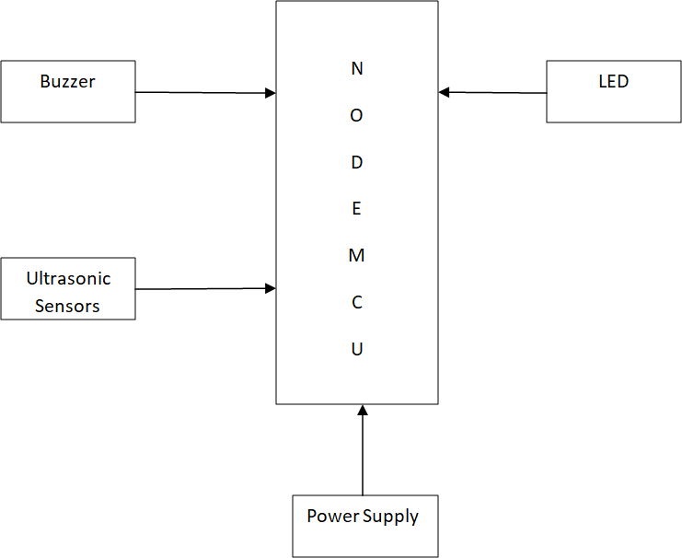

Fig 3.1: METHODOLOGY

The proposed system is used to detect the vehicles on one side of the hairpin and assist the vehicle coming opposite to it. The aim of the proposed system is to classify different vehicles passing through one direction of the hairpin road and notify the vehicles coming from the opposite direction of the hairpin through a display board.

This display board contains information about vehicle category, time taken to pass the vehicle at the curve, and the number of vehicles in the curve.

This paper contains a set of ultrasonic sensors, warning lights combined with a convex mirror is installed by the side of the road. Wires link the sensors, which are mutually exclusive. The priority algorithm automatically limits vehicle travel at the hairpin curve based on sensor data, providing appropriate alerts when detection is detected. The appropriate warningis triggered for various scenarios, prioritizing the vehicle's movement. In the event of a system failure, a caution LED is activated, which sends a signal to the maintenance department.

The technology is developed in such a way that it may be used by a regular car drivers. Automobiles have become one of humanity's greatest economic triumphs. In the last century, they were sadly prone to accidents and became victims while travelling. Sensors monitor the position of the vehicles in relation to the hairpin turn to determine which Vehicles must move first. The system captures information exchange between vehicles. The decision regarding speed and distance is passed on to the vehicle via a visual display. The hardware and software architecture are designed and developed. throughout the project is detailed in this paper.

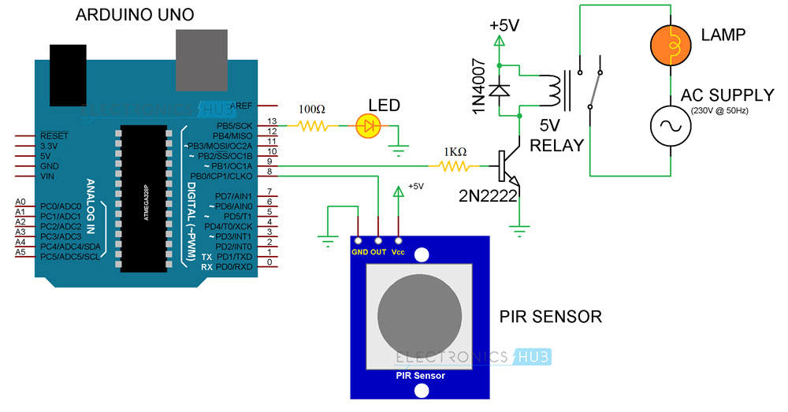 Fig 3.2: ARCHITECTURE

## WORKING:

This system reads vehicles using the Webcam or gives a video as input. The next step is image acquisition. The CNN algorithm is used for real-time classification of vehicles. Based on the size of vehicles, they are classified into light motor vehicles (LMV) and heavy motor vehicles (HMV). This algorithm helps predict the vehicle class and count the number of vehicles. The predicted value is then stored in a database. The predicted values from both uphill and downhill are stored in the database. From this database, the comparison is happening.

## SYSTEM DESIGN:

The paper proposes that light vehicles, such as cars and jeeps, can make a small turn, whereas heavy vehicles, such as buses and trucks, take a longer turn. As heavier vehicles take longer to turn, they can take the entire hairpin curve, forcing other vehicle to wait until the heavy vehicle passes the curve. Light vehicle, on the other hand, take a shorter turn, so only half of the hairpin curve is occupied, leaving the other half unoccupied. If the other vehicle is also a light vehicle, it can occupy the remaining half and pass through the curve.

## RELATED WORK:

Driving is one of the most challenging tasks in the hills. While driving in these areas, drivers must stay alert at all times. The driver does not see the car approaching from the opposite side in curves and hairpin bends, which is one of the leading causes of accidents in mountainous areas. A multitude of curves and hairpin bends can be found in mountainous areas. In these areas, the roadway is a popular form of transportation. In hilly areas, the number of accidents and deaths is steadily rising. Because the roads in this area will almost certainly feature twists and sharp curves, it will be difficult to see vehicles approaching from the other direction

# 3.4 ALGORITHMS USED

There are some cases of vehicles approaching hairpin bends:

Case-1 (LMV from uphill and downhill): The LMV takes a short turn, so the display board will show the "GO" signal for the LMV coming from both sides of the curve, number of vehicles and time taken by the vehicles to pass the curve.

Case-2(LMV from one side and HMV from other side): The LMV takes a short turn, whereas the HMV takes a longer turn, so the display board will show the "STOP" signal for the LMV and “GO” signal for HMV. The display will show the time taken by HMV to complete the turn.

Case-3 (HMV from uphill and downhill): As the HMV takes a longer turn, the display board will show the "STOP" signal to the HMV coming from downhill and the time taken by the HMV from uphill to pass the turn. Industrial lighting in retailers and offices uses bit high power, so they will create use of passive infrared sensors or super sonic sensors to cover massive areas. outside and Industrial sectors will create use of Pyroelectric Infrared(PIR), light and motion sensors so as to manage the light in a very safety and value effective manner.

It provides new platform to develop our new ideas and concepts. There are several journal papers that have been published based on smart light which is the hot topic in the current research. Efforts are made to improve the approaches for the lighting system for better efficiency and low power consumption with hybrid approaches.

# SOFTWARE COMPONENTS

**Arduino IDE:**

The Arduino Integrated Development Environment (IDE) is a software that connects to the Arduino boards to upload programs and communicate with them. It contains a text editor for writing code, a message area, a text console, a toolbar with buttons for common functions, and a series of menus. Programs written using Arduino Software (IDE) are called sketches, which are written in the text editor and saved with the file extension. ino . The IDE is available for download on the Arduino website and can be used with any Arduino board. There are currently two versions of the Arduino IDE: IDE 1.x.x and IDE 2.x. IDE 2.x is a new major release that is faster and more powerful than IDE 1.x.x, with advanced features to help users with their coding and debugging.

# MODULES

1. PIR sensor (2 No’s)

2.Arduino Nano board

3.PCB Board

4.Double channel relay

5.Arduino IDE

6.Power supply Adapter

7.LDR Module

8.LED indicator

9.DC Converter

10.Lamp Post

PIR sensor enable you to sense motion occured, nearly always used to find whether an individual's has enraptured in or out of sensors range. They are little, cheap, low power, simple to use and do not wear out. For that reason they are usually found in appliances and gadgets utilized in homes or industries. They are usually noted as PIR, " PassiveInfrared ", "Pyro electric", or " IRmotion " sensors. PIRs are mainly made using a pyroelectric sensing element which might detects level of infrared radiation. Everything emit some low level radiations, and also the hotter something is in the range, the additional radiation will be emitted. The sensing element in motion detector is really split in into two halves inside the system. The reason for that is that we are looking to find motion (changes) not average IR levels. the two halves will be wired up so they can cancel one another out. If one half see more or less IR radiations than the opposite , the output may swing high or low.

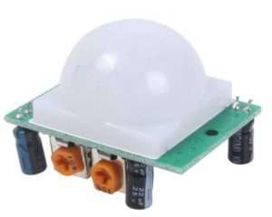

Fig 4.1: PIR SENSOR

The Arduino pro mini is meant for semi-permanent installation in object or exhibition. The board comes without pre mounted headers, permitting the use of various forms of connectors or direct soldering of wire. The pin layout is compatible with the Arduino mini .There are 2 version of the pro mini. One runs at 3V and eight megahertz, the other at 5V and sixteen megahertz The Arduino was designed and is factory made by Spark gun natural philosophy.

**4.3.1 IR SENSOR**

IR sensor enable you to sense object occured, nearly always used to find whether an individual's has enraptured in or out of sensors range. They are little, cheap, low power, simple to use and do not wear out. For that reason they are usually found in appliances and gadgets utilized in homes or industries. They are usually noted as IR, " Infrared ", "Pyro electric", or " IR motion " sensors. PIRs are mainly made using a pyroelectric sensing element which might detects level of infrared radiation. Everything emit some low level radiations, and also the hotter something is in the range, the additional radiation will be emitted. The sensing element in motion detector is really split in into two halves inside the system. The reason for that is that we are looking to find motion (changes) not average IR levels. the two halves will be wired up so they can cancel one another out. If one half see more or less IR radiations than the opposite , the output may swing high or low.

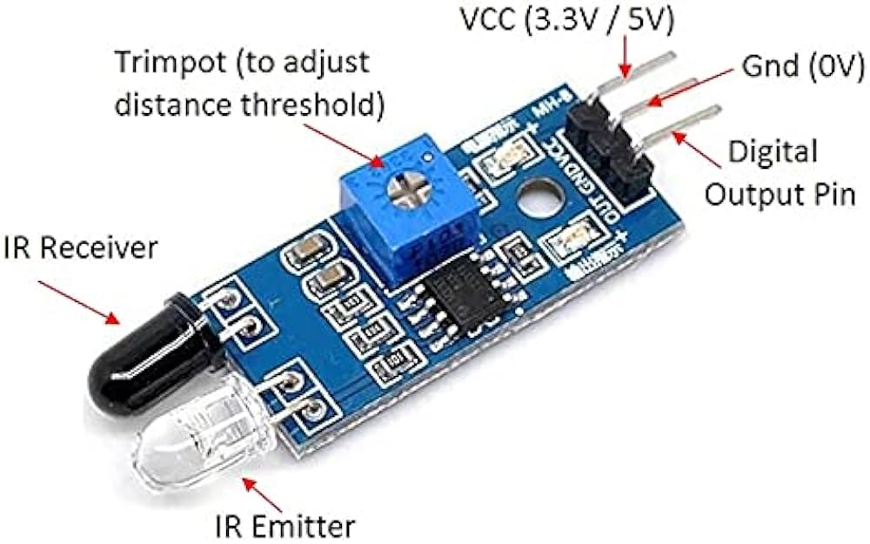

Fig 4.2.: IR SENSOR

The Arduino pro mini is meant for semi-permanent installation in object or exhibition. The board comes without pre mounted headers, permitting the use of various forms of connectors or direct soldering of wire. The pin layout is compatible with the Arduino mini .There are 2 version of the pro mini. One runs at 3V and eight megahertz, the other at 5V and sixteen megahertz The Arduino was designed and is factory made by Spark gun natural philosophy.

**4.3.2 SSR RELAY**

A power supply circuit is a very basic circuit in learning electronics. The power supply which we will design here is very basic and it is a linear technology based design which will go through each design step. The design of any circuit begins with a well-made general block diagram. It helps to design the sections of the circuit individually and then at the end put them together to have a complete circuit which is ready for use

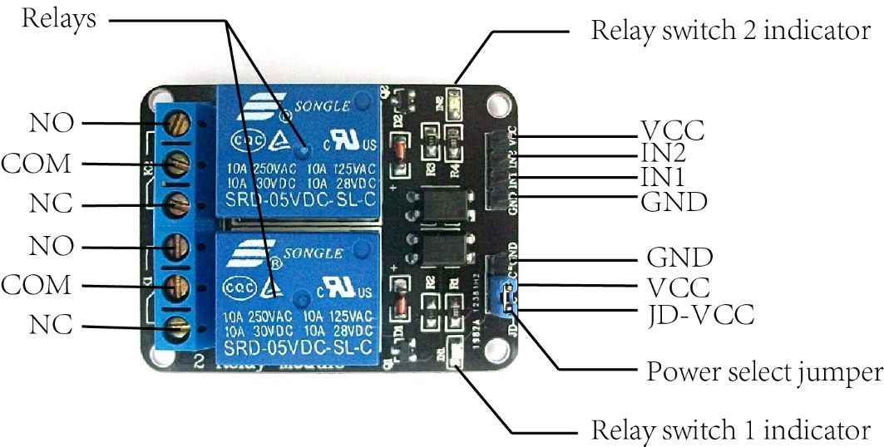

Fig 4.3: SSR RELAY

The people work late nights and also most of the criminal activities occur during nights. Under these circumstances, to provide security, controlling and also for monitoring of street light is developed together with GUI. Even the usage of solar panel is helpful for saving power and money. At the PC side, graphical user interface take part in controlling the street lighting. For monitoring and controlling the lights on streets, Zigbee technology is used. More power and energy will be saved by using SSR and IS sensors. Basically this proposed model works on the two operational modes. They are auto and manual modes. In auto mode On-Off of the lighting are done by using SSR which measures the intensity of light. Controlling is by use of relay.

Arduino Nano is a small, compatible, flexible and breadboard friendly Microcontroller board, developed by Arduino.cc in Italy, based on ATmega328p / Atmega168. It comes with exactly the same functionality as in Arduino NANO but quite in small size. It comes with an operating voltage of 5V and the input voltage can vary from 7 to 12V.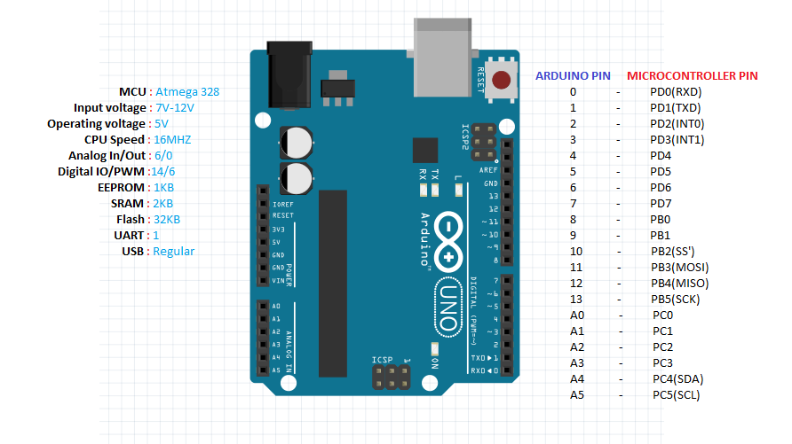

Fig 4.4: MICROCONTROLLER

An Arduino is an open-source microcontroller development board. In plain English, you can use the Arduino to read sensors and control things like motors and lights. The technology is developed in such a way that it may be used by a regular car drivers. Automobiles have become one of humanity's greatest economic triumphs. In the last century, they were sadly prone to accidents and became victims while travelling. This allows you to upload programs to this board which can then interact with things in the real world. With this, you can make devices which respond and react to the world at large.

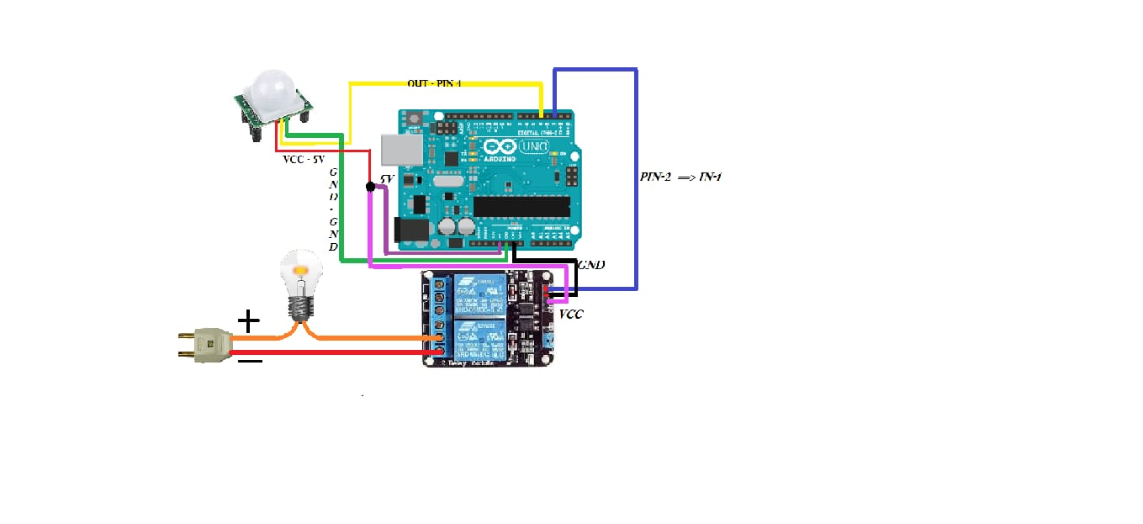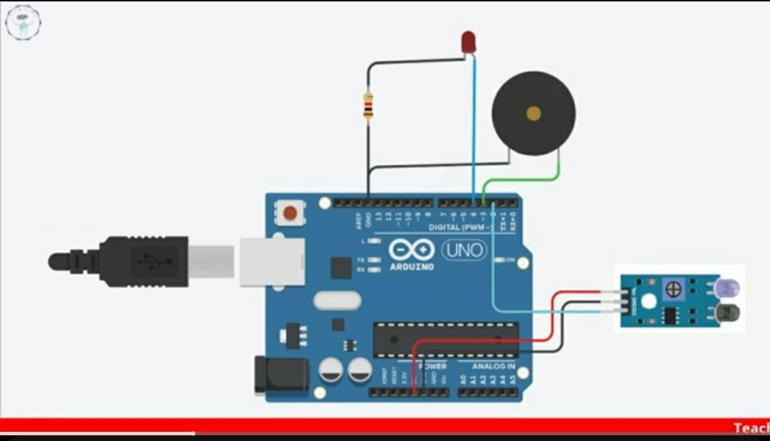**5.1 CIRCUIT DIAGRAMS**

**5.2 Smart Lights Circuit diagram** :

# 5.1 Alert with indicate Circuit diagram :

# 5.2 OUTCOME OF THE SYSTEM

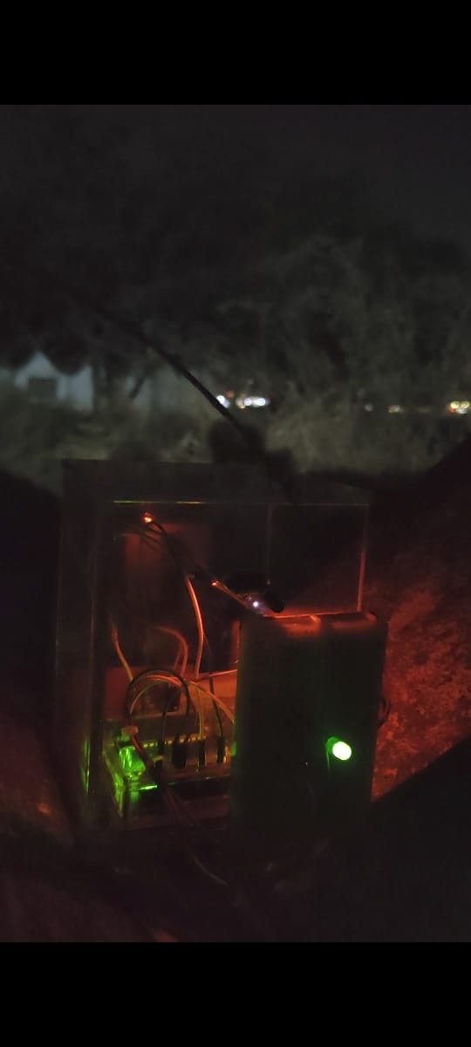

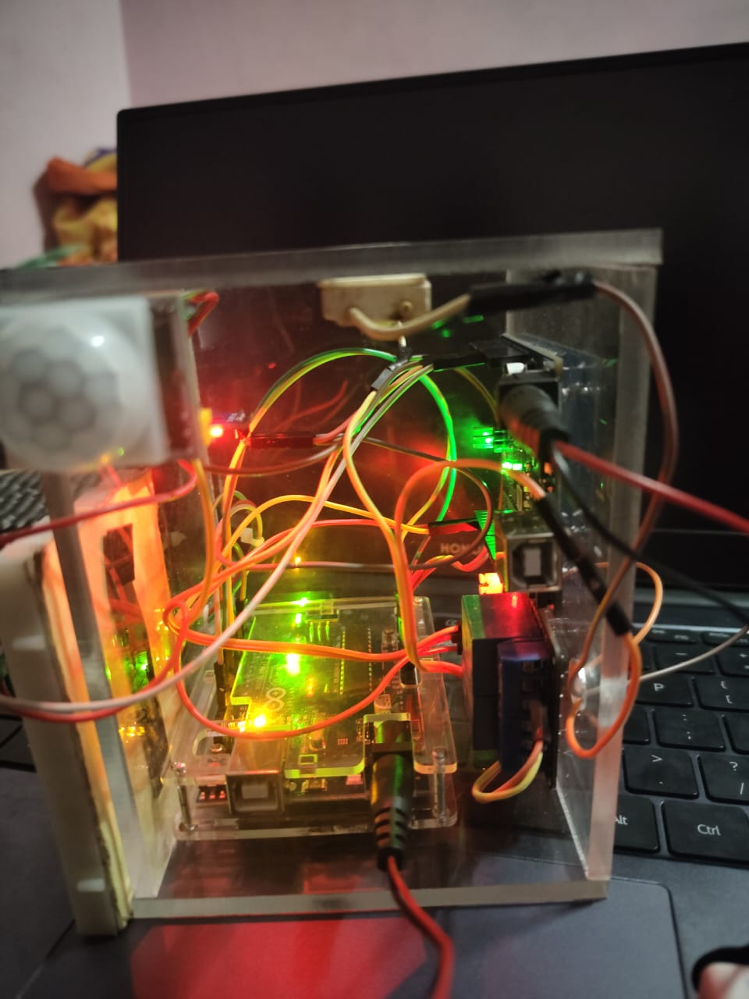

Fig 5.3: OUTCOME OF THE SYSTEM

# 5.3 FINAL OUTCOME

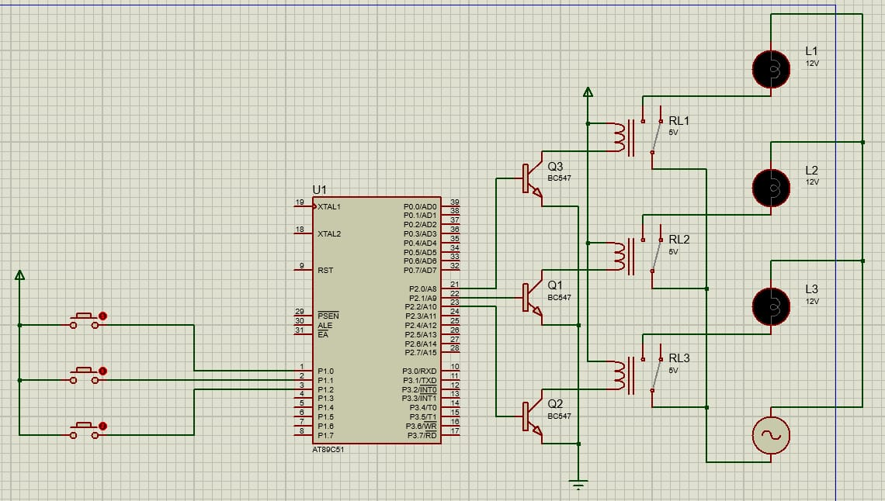

Fig 5.4: FINAL OUTCOME

The output/report of the application will have detailed report on the below-mentioned functions:

The proposed system helps with accident avoidance and effective traffic management in hairpin curves. In the future, there could be more functionalities that can be added. Some functionalities can be added to the camera in hairpin curves to record the vehicle and its number from the number plate, so that if an accident happens, then details of the vehicle can be taken from the camera and also investigate that accident by checking the footage. A warning system can be added if a vehicle crosses the opposite lane.

The reason for that As a result, vehicles must take extreme caution when driving through hairpin curves. The existing systems detect only the incoming vehicles and not the type of vehicle. As a result, there is traffic congestion and delay in travel. The aim of proposed system is to classify different vehicles passing through one direction of the hairpin road and notify the vehicles those coming opposite direction of hairpin through a display board.

People have become much more reliant on transportation systems in recent years, and transportation systems themselves confront both opportunities and limitations. The world's population continues to rise, posing a significant challenge to transportation management systems.The vehicle moving through hairpin bends are very much susceptible to accidents due to lack of communication and zero visibility over the hairpin curves. Hence, drivers must be extremely cautious while driving in hairpin curves. The proposed system aims to reduce traffic congestion and prevent collisions in hairpin curves as much as possible, allowing for easy vehicle movement in hilly areas.So the drivers can easily drive through hairpin curves and accidents can be prevented. It is not easy task to design this system using PIR sensors where PIR is generally used for the motion detection. We have done coding in such a way that little movement of the human body is detected by the sensor. We have made some time delay and adjusted the sampling period for the sensor output for the precise detection for this system. In this system we are taking decision based on Human presence but we can also interface LDR (Light Dependent Resistor) Sensor and Temperature sensor for better working of the system for energy saving. This system can be also interfaced with the Bluetooth module so that, we can control the whole system from the mobile phone itself.

**REFERENCES**

[1].Soyoung Hwang and Donghui Yu, “Remote monitoring and Controlling System Based on Zigbee Networks” International Journal of Software Engineering and Its Application Vol. 6, No. 3, July,2012.

[2].Richu Sam Alex, R NarcissStarbell “ Energy efficient Intelligent Street Light System using Zigbee and Sensor”, International Journal of Engineering and advanced Technology (IJEAT), Vol-3, Issue 4, april 2014.

[3].Daeho Kim, Junghoon Lee, Yeongmin Jang and Jaesang Cha . “ Smart LED light system implementation using Human tracking US/IR sensor ” 2011 IEEE (ICTC 2011).

[4].B.K Subramanyam, K Bhaskar Reddy, P. Ajay Kumar Reddy, “ Design and Development Of intelligent wireless Street lighting control and monitoring system along with GUI ”, International Journal of Engineering Research and Application (IJERA) ISSN: 2248-9622 [www.ijera.com](http://www.ijera.com/) Vol. 3, Issue 4, Jul-Aug 2013.

[5].RajaR , Dr.K.Udhayakumar ” Development in Smart Sensor Network for Energy Saving” International Journal of advanced Research in Electrical, electronics and instrumentation Engineering (An ISO 3297: 2007 Certified Organization) Vol. 3, Special Issue 2, April 2014.

[6].Michale Mango, Tommaso Poloneli , Luca Benini “ A Low Cost and Highly Scalable Wireless Sensor Network Solution to Achieve Smart LED Light Control for Green Buildings” IEEE Senosrs Journal, VOL. 15, NO. 5, MAY 20.

[7] Anuradha A, Trupti Tagare, Vibha T. G and Priyanka N, “Implementation of Critical Intimation System for Avoiding Accidents in Hairpin Curves & Foggy Areas”, International Journal of Science Technology & Engineering, Volume: 05, Issue: 05, November 2018.

[8] Avinash Shetty, Bhavish Bhat, RameshaKarantha and Srinivasa Hebbar, “Smart Transport System Signalling Sensor System Near Hairpin Bends”, International Journal of Scientific & Engineering Research, Volume: 09, Issue: 04, April 2018.

[9] V.Ramachandran, R.Ramalakshmi and K. Mathankumar, “Accident Prevention and Traffic Pattern Analysis System for Hilly Regions”, International Journal of Innovative Technology and Exploring Engineering, Volume: 09, Issue: 02, December 2019.

**APPENDICES**

**APPENDIX - I**

**SOURCE CODE**

ALERT AND INDICATION CODE :

/* Arduino with PIR motion sensor

For complete project details, visit: http://RandomNerdTutorials.com/pirsensor

Modified by Rui Santos based on PIR sensor by Limor Fried

*/

int led = 13; // the pin that the LED is atteched to

int sensor = 2; // the pin that the sensor is atteched to

int state = LOW; // by default, no motion detected

int val = 0; // variable to store the sensor status (value)

void setup() {

pinMode(led, OUTPUT); // initalize LED as an output

pinMode(sensor, INPUT); // initialize sensor as an input

Serial.begin(9600); // initialize serial

}

void loop(){

val = digitalRead(sensor); // read sensor value

if (val == HIGH) { // check if the sensor is HIGH

digitalWrite(led, HIGH); // turn LED ON

delay(100); // delay 100 milliseconds

if (state == LOW) {

Serial.println("Motion detected!");

state = HIGH; // update variable state to HIGH

}

}

else {

digitalWrite(led, LOW); // turn LED OFF

delay(200); // delay 200 milliseconds

if (state == HIGH){

Serial.println("Motion stopped!");

state = LOW; // update variable state to LOW

}

}

}

SMART LIGHTS CODE:

#include <ESP8266WiFi.h> // Thư viện dùng để kết nối WiFi của ESP8266

#include <PubSubClient.h> // Thư viện dùng để connect, publish/subscribe MQTT

#include <string.h>

#include <ArduinoJson.h>

#include <SoftwareSerial.h>

// const char* ssid = "Huflit-GV"; // Tên của mạng WiFi mà bạn muốn kết nối đến

// const char* password = "gvhuflit@123"; // Mật khẩu của mạng WiFi

// const char* ssid = "Lucid Coffee 2.4G"; // Tên của mạng WiFi mà bạn muốn kết nối đến

// const char* password = "lucidcoffee"; // Mật khẩu của mạng WiFi

const char* ssid = "Sho0_"; // Tên của mạng WiFi mà bạn muốn kết nối đến

const char* password = "sownnnnn"; // Mật khẩu của mạng WiFi

const char* mqttServer = "broker.hivemq.com";

const int mqttPort = 1883;

const char* mqttUser = "Sho";

const char* mqttPassword = "1234";

const String name = "1";

int led;

long water;

float t;

float h;

char buffer[256];

StaticJsonDocument<300> doc;

String mode = "auto";

SoftwareSerial serial_ESP(D2, D3); //D2 = RX -- D3 = TX

#define ledpin D1

#define motionpin D7

char messageBuff[100]; // Biến dùng để lưu nội dung tin nhắn

WiFiClient espClient;

PubSubClient client(espClient);

void setup() {

pinMode(ledpin, OUTPUT);

pinMode(motionpin, INPUT);

pinMode(D2, INPUT);

pinMode(D3, OUTPUT);

Serial.begin(9600);

serial_ESP.begin(115200);

startWiFi();

connectBroker();

client.subscribe("sho/temp");

client.publish("sho/temp", "Connected");

}

void loop() {

if (!client.connected()) {

connectBroker();

}

client.loop();

if (mode == "auto"){

if (serial_ESP.available()) {

DeserializationError err = deserializeJson(doc, serial_ESP);

String dataRecive = serial_ESP.readString();

serializeJson(doc, buffer);

if (err == DeserializationError::Ok) {

Serial.println("Led: " + String(doc["Led"].as<float>()) + " | Water: " + String(doc["Water"].as<float>()) + " | Temp: " + String(doc["Temp"].as<float>()) + " | Humd: " + String(doc["Humid"].as<float>()));

}

led = doc["Led"];

int motion = digitalRead(motionpin);

Serial.println("Motion: " + String(motion));

if (led == 50) {

if (motion == 1) {

led = 255;

}

}

client.publish("sho/temp", buffer);

}

}

}

void startWiFi() {

WiFi.begin(ssid, password); // Kết nối vào mạng WiFi

Serial.print("Connecting to ");

Serial.print(ssid);

// Chờ kết nối WiFi được thiết lập

while (WiFi.status() != WL_CONNECTED) {

delay(1000);

Serial.print(".");

}

Serial.println("\n");

Serial.println("Connection established!");

Serial.print("IP address: ");

Serial.println(WiFi.localIP()); // Gởi địa chỉ IP đến máy tinh

}

void connectBroker() {

client.setServer(mqttServer, mqttPort);

client.setCallback(callback);

while (!client.connected()) {

Serial.print("Connecting to MQTT...");

if (client.connect("ShoPucID")) { // Kêt nối đến broker thành công

Serial.println("\n");

Serial.println("MQTT connected");

} else {

Serial.println("\n");

Serial.print("MQTT failed with state ");

Serial.println(client.state());

delay(2000);

}

}

}

void callback(char* topic, byte* payload, unsigned int length) {

Serial.print("Message arrived [");

Serial.print(topic);

Serial.print("] ");

int i;

for (i = 0; i < length; i++) {

messageBuff[i] = (char)payload[i];

}

messageBuff[i] = '\0';

String message = String(messageBuff);

if (message.indexOf("control") >= 0) {

deserializeJson(doc, message);

mode = "control";

String leds = doc["Led"];

int level = doc["Level"];

Serial.println("CONTROL");

Serial.println(leds);

Serial.println(String(level));

if (leds.indexOf(name) >= 0) {

analogWrite(ledpin, level);

}

if (leds.indexOf("all") >= 0) {

analogWrite(ledpin, level);

}

}

else if (message.indexOf("auto") >= 0){

mode = "auto";

}

if (mode=="auto"){

analogWrite(ledpin, led);

}

}